TECHNICAL DESCRIPTION OF FIBER OPTIC CABLE
Cable construction
Cable type | A-D(ZN)2Y-(4-24)/A-D(ZN)4Y-(4-24)-7204
Standards | IEC 60793, IEC 60794
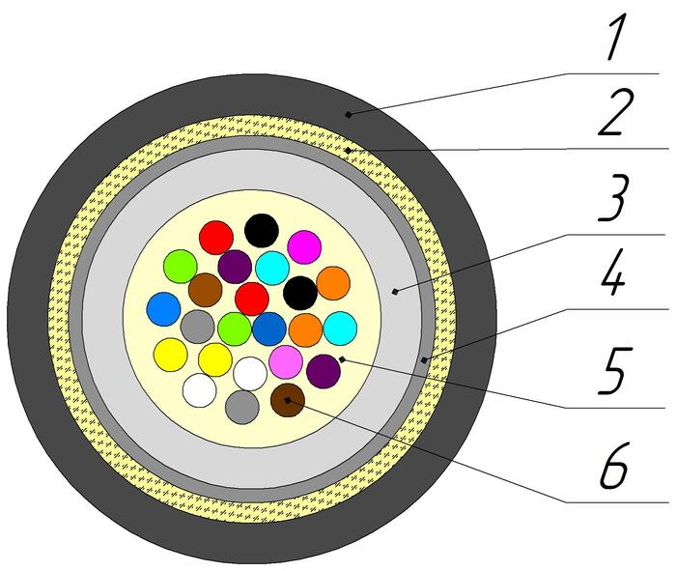
Cable construction
1. Outer sheath: UV-resistant PЕ/PA
2. Strength element of core: aramid yarns
3. The first layer of the loose tube: PC
4. The second layer of the loose tube: PBT
Optical loose tube: PBT\PC Tube
5. Intramodule compound: Thixotropic compound
6. Optical Fiber: Single-mode Fiber
Temperature ranges | Storage and transportation temperature | Installation temperature | Operating temperature
Temperature ranges | from -20 to +70 °С | from -10 to +60 °С | from -20 to +70 °С
Resistance to water penetration | Water resistant
Relative humidity at +35⁰ C, % | 98
Outer diameter, mm | 3,4±0,2
Average weight of 1 km of the cable, kg | 10±5%

Mechanical characteristics
Calculated tensile strength, not less than, kN  Dynamic | 0,25
Minimum bending radius | 15D
Short-term crush test, kN/cm (N/10cm) | 0,1 (1000)
Resistance to axial torsion at angle ±360° on 1 m length cable | Resistant
Resistance to bends at angle ± 90⁰ with a radius equal to 15 nominal cable diameters | Resistant
Resistance to impact 2 J | Resistant

Packaging and marking
Cable factory length, km | 6
Package | Coil ОККО №2 (600x450x600)
Tolerance, % | ±3,0
Short lengths (customer approval) | Maximum 5%
Marking method | Inkjet printing
The accuracy of marking, % | ±0,5

Coloring
Coloring of fibers in loose tube (According to Customer’s requirements color can be different). M-fiber with black ring mark.
1 | 2 | 3 | 4 | 5 | 6 | 7 | 8 | 9 | 10 | 11 | 12
red | green | blue | yellow | white | slate | brown | violet | aqua | black | orange | pink
13 | 14 | 15 | 16 | 17 | 18 | 19 | 20 | 21 | 22 | 23 | 24
red+m | green+m | blue+m | yellow+m | white+m | slate+m | brown+m | violet+m | aqua+m | transparent | orange+m | pink+m

Cable sheath coloring
Sheath material | PE | PA
Color | black | orange

Can be used: - 250 µm Single-mode Fiber according to ITU-T G.652.D or G.652.D/G.657.A1 - 200 µm Single-mode Fiber according to ITU-T G.652.D/G.657.A1
Tensile strength value is for maximum number of fibers design

