TECHNICAL DESCRIPTION OF FIBER OPTIC CABLE
Cable construction
Cable type | A-DQ(ZN)B2Y-(1-8)x12-6329
Standards | IEC 60793, IEC 60794
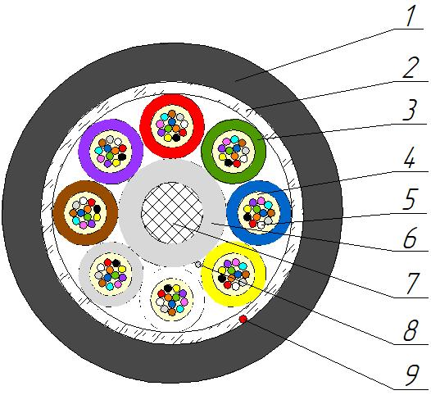
Cable construction
1. Outer sheath: UV-resistant PЕ
2. Peripheral water-blocking strength element: Water swellable glass yarn
3. Optical loose tube: PBT Tube
4. Intramodule compound: Thixotropic compound
5. Optical Fiber: Single-mode Fiber according to ITU-T G. 652.D or G.652.D/G.657.A1
6. Insulation of central strength element: PЕ
7. Central strength element: Glass reinforced plastic FRP-E
8. Water-blocking element of core: Water-swellable yarn
9. Rip-cord: Synthetic yarn
Temperature ranges | Storage and transportation temperature | Installation temperature | Operating temperature
Temperature ranges | from -40 to +70 °С | from -5 to +50 °С | from -20 to +70 °С
Resistance to water penetration | Water resistant
Relative humidity at +35⁰ C, % | 98
Outer diameter, mm | 11,1±0,2
Average weight of 1 km of the cable, kg | 100±5%

Mechanical characteristics
Calculated tensile strength, not less than, kN  Dynamic | 3
Minimum bending radius | 20D
Short-term crush test, kN/cm (N/10cm) | 0,2 (2000)
Resistance to axial torsion at angle ±360° on 4 m length cable | Resistant
Resistance to bends at angle ± 90⁰ with a radius equal to 20 nominal cable diameters | Resistant
Resistance to impact 10 J | Resistant

Packaging and marking
Cable factory length, km | 6
Package | Drum №14g (1400х1015х1400)
Tolerance, % | ±3,0
Short lengths (customer approval) | Maximum 5%
Marking method | Inkjet printing
The accuracy of marking, % | ±0,5

Coloring
Coloring of fibers in loose tube (According to Customer’s requirements color can be different).
1 | 2 | 3 | 4 | 5 | 6 | 7 | 8 | 9 | 10 | 11 | 12
red | green | blue | yellow | white | slate | brown | violet | aqua | black | orange | pink

Coloring of optical loose tube (According to Customer’s requirements color can be different). Core-filler color is natural.
1 | 2 | 3 | 4 | 5 | 6 | 7 | 8
red | green | blue | yellow | white | slate | brown | violet

Product data
Fiber count | 12 | 24 | 36 | 48 | 72 | 96
Loose tubes x fibers | 1х12 | 2х12 | 3x12 | 4х12 | 6х12 | 8x12

Tensile strength value is for maximum number of fibers design

