TECHNICAL DESCRIPTION OF FIBER OPTIC CABLE
Cable construction
Cable type | A-DQ(ZN)2Y-(1-6)x24/A-DQ(ZN)4Y-(1-6)x24-10145
Standards | IEC 60793, IEC 60794
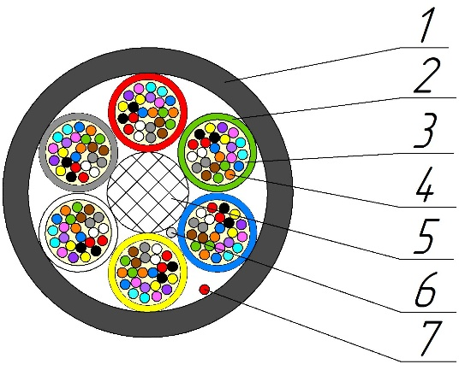
Cable construction
- Outer sheath: UV-resistant PЕ/PA
- Optical loose tube: PBT Tube
- Intramodule compound: Thixotropic compound
- Optical Fiber: 200 µm Single-mode Fiber according to ITU-T G.652.D/G.657.A1
- Central strength element: Glass reinforced plastic FRP-E
- Water-blocking element of core: Water-swellable yarn
- Rip-cord: Water-swellable yarn
Temperature ranges | Storage and transportation temperature | Installation temperature | Operating temperature
Temperature ranges | from -30 to +70 °С | from -5 to +50 °С | from -30 to +70 °С
Resistance to water penetration | Water resistant
Relative humidity at +35⁰ C, % | 98
Outer diameter, mm | 5,7±0,2
Average weight of 1 km of the cable, kg | 20±5%

Mechanical characteristics
Calculated tensile strength, not less than, kN  Dynamic | 0,8
Minimum bending radius | 20D
Short-term crush test, kN/cm (N/10cm) | 0,05 (500)
Resistance to axial torsion at angle ±360° on 2 m length cable | Resistant
Resistance to bends at angle ± 90⁰ with a radius equal to 20 nominal cable diameters | Resistant
Resistance to impact 2 J | Resistant

Packaging and marking
Cable factory length, km | 6
Package | Drum №10 (1000х630х1000)
Tolerance, % | ±3,0
Short lengths (customer approval) | Maximum 5%
Marking method | Inkjet printing
The accuracy of marking, % | ±0,5

Coloring
Coloring of fibers in loose tube (According to Customer’s requirements color can be different). M-fiber with black ring mark.
1 | 2 | 3 | 4 | 5 | 6 | 7 | 8 | 9 | 10 | 11 | 12
red | green | blue | yellow | white | slate | brown | violet | aqua | black | orange | pink
13 | 14 | 15 | 16 | 17 | 18 | 19 | 20 | 21 | 22 | 23 | 24
red+m | green+m | blue+m | yellow+m | white+m | slate+m | brown+m | violet+m | aqua+m | transparent | orange+m | pink+m

Coloring of optical loose tube (According to Customer’s requirements color can be different). Core-filler color is natural.
1 | 2 | 3 | 4 | 5 | 6
red | green | blue | yellow | white | slate

Cable sheath coloring
Sheath material | PE/PA
Color | black | orange

Product data
Fiber count | 24 | 48 | 72 | 96 | 144
Loose tubes x fibers | 1х24 | 2х24 | 3х24 | 4х24 | 6х24

Tensile strength value is for maximum number of fibers design

