TECHNICAL DESCRIPTION OF FIBER OPTIC CABLE
- Cable construction
Cable type | A-DQ(ZN)2Y-12-G.652.D/G.657.A1-7203
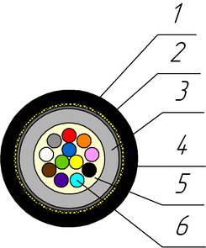
Cable construction
1. Outer sheath: UV-resistant PЕ
2. Strength element of core:aramid yarns
3. The first layer of the loose tube: PC
4. The second layer of the loose tube: PBT
Optical loose tube: 1,85 mm PBT\PC Tube
5. Intramodule compound: Thixotropic compound
6. Optical Fiber: Single-mode Fibre according to ITU-T G.652.D and G.657.A1
Temperature ranges | Storage and transportation temperature | Installation temperature | Operating temperature
Temperature ranges | from -40 to +70 °С | from -10 to +60 °С | from -30 to +70 °С
Resistance to water penetration | Water resistant
Relative humidity at +35⁰ C, % | 98
Outer diameter, mm | 2,4±0,2
Average weight of 1 km of the cable, kg | 5±5%

- Mechanical characteristics
Calculated tensile strength, not less than, kN  Dynamic | 0,2
Minimum bending radius | 15D
Short-term crush test, kN/cm (N/10cm) | 0,1 (1000)
Resistance to axial torsion at angle ±360° on 1 m length cable | Resistant
Resistance to bends at angle ± 90⁰ with a radius equal to 15 nominal cable diameters | Resistant
Resistance to impact 2 J | Resistant
- Packaging and marking
Cable factory length, km | 6
Package | Coil ОККО №1 (495х445х495)
Tolerance, % | ±3,0
Short lengths (customer approval) | Maximum 5%
Marking method | Inkjet printing
The accuracy of marking, % | ±0,5

- Coloring
Coloring of fibers in loose tube (According to Customer’s requirements color can be different).
1 | 2 | 3 | 4 | 5 | 6 | 7 | 8 | 9 | 10 | 11 | 12
red | green | blue | yellow | white | slate | brown | violet | aqua | black | orange | pink

- Product data
Fiber count | 12
Loose tubes x fibers | 1x12

Tensile strength value is for maximum number of fibers design

