TECHNICAL DESCRIPTION OF FIBER OPTIC CABLE

Cable type A-DQ(ZN)В2Y 16x12-G.652.D-UCF-6309

Cable formula F-PBT+ FGA-PE

 | 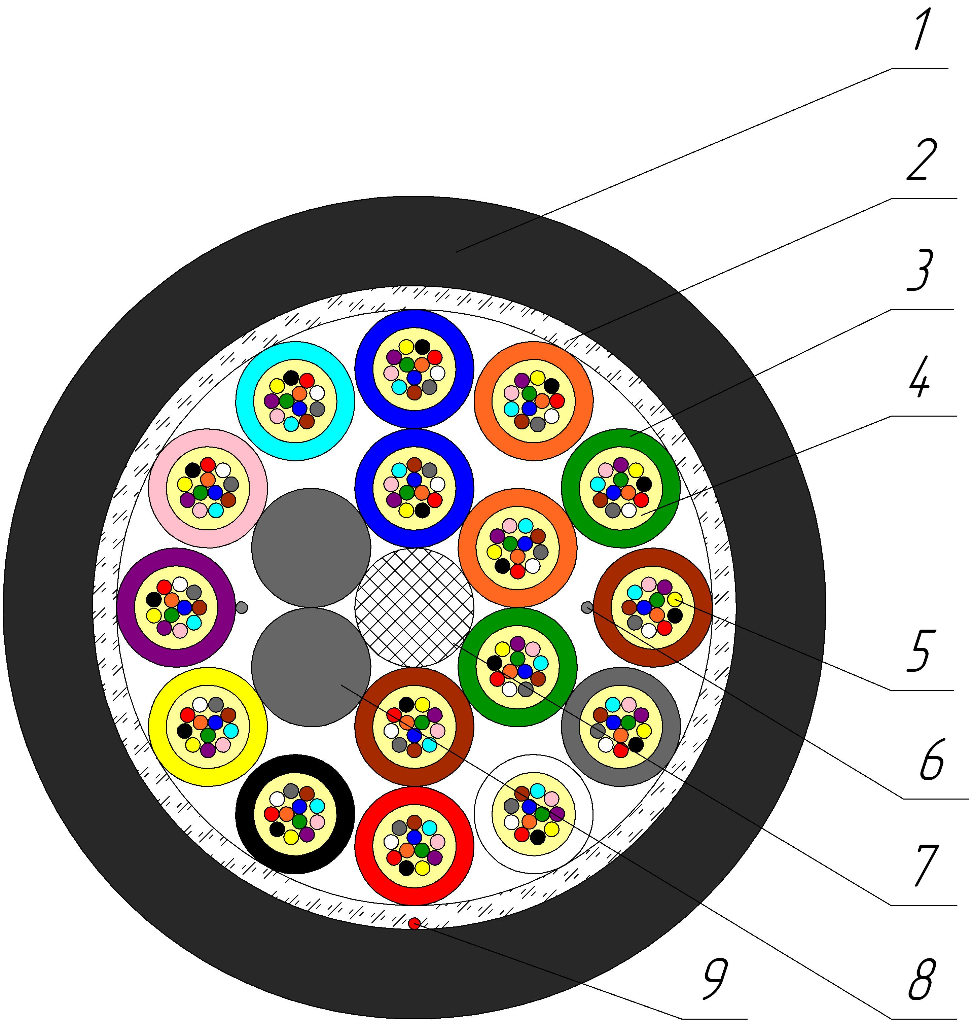 | 1. Outer sheath  2. Peripheral water-blocking strength element  3. Optical loose tube  4. Intramodule compound  5. Optical Fiber  6. Water-blocking element  7. Central strength element  8. Core-filler  9. Rip-cord
Cable construction
Outer sheath |  |  | UV-resistant PE
Peripheral water-blocking strength element |  |  | Water-swellable yarn
Optical loose tube |  |  | 2,0mm PBT tube
Intramodule compound |  |  | Thixotropic compound
Optical Fiber |  |  | Corning ® SMF-28® Ultra Optical Fiber according to ITU-T G.652.D and G.657.A1
Water-blocking element |  |  | Water-swellable yarn
Central strength element |  |  | Glass reinforced plastic 2,0mm FRP-E
Core-filler |  |  | PE
Rip-cord |  |  | Synthetic yarn
Coloring of fibers in loose tube (According to Customer’s requirements color can be different) |  |  | Fiber №1  Fiber №2  Fiber №3  Fiber №4  Fiber №5  Fiber №6  Fiber №7  Fiber №8  Fiber №9  Fiber №10  Fiber №11  Fiber №12 | Blue  Orange  Green  Brown  Grey  White  Red  Black  Yellow  Purple  Rose  Aqua
Coloring of optical loose tube (According to Customer’s requirements color can be different) |  |  | 1-st layer  Loose tube №1  Loose tube №2  Loose tube №3  Loose tube №4  Core-filler  Core-filler  2-st layer  Loose tube №5  Loose tube №6  Loose tube №7  Loose tube №8  Loose tube №9  Loose tube №10  Loose tube №11  Loose tube №12 Loose tube №13  Loose tube №14  Loose tube №15  Loose tube №16 | Blue  Orange  Green  Brown  Natural  Natural  Blue  Orange  Green  Brown  Grey  White  Red  Black  Yellow  Purple  Rose  Aqua
Number of the elements in a layer |  |  | 1+6+12
Average weight of 1 km of the cable, kg |  |  | 151,6
Average outer diameter (D), mm |  |  | 14,0±0,2
Optical parameters
Operation wavelength, nm |  |  | 1310-1550
Attenuation coefficient at wavelength, dB/km, not more than  1310 nm  1383 nm  1550 nm |  |  | 0,36  0,35  0,22
Mechanical characteristics
Calculated tensile strength, not less than, kN  Dynamic |  |  | 3,0
Minimum bending radius |  |  | 20D
Short-term crush test, kN/cm (N/10cm) |  |  | 0,3 (3000)
Resistance to axial torsion at angle ± 360⁰ on 4 m length cable |  |  | Resistant
Resistance to bends at angle ± 90⁰ with a radius equal to 20 nominal cable diameters |  |  | Resistant
Resistance to impact 15,0 J |  |  | Resistant
Operating temperature |  |  | from -30 tо +70 °С
Installation temperature |  |  | from -15 tо +50 °С
Storage and transportation temperature |  |  | from -40 tо +70 °С
Resistance to water penetration |  |  | Water resistant
Relative humidity at +35⁰ C, % |  |  | 98
Cable factory length, km |  |  | 5,0/6,0
Package |  |  | Drum №17 (1765х940х1765)/  Drum №18b (1870х1350х1870)
Tolerance, % |  |  | ±3
Short lengths (customer approval) |  |  | Maximum 5%
The accuracy of marking |  |  | ±0,5

